PDPL-AR Compliance for Log360
Strengthen data protection and meet PDPL-AR compliance with Log360.
Region: EU | Type: Data Privacy | Category: Compliance | Pricing: Free

Overview
The PDPL-AR compliance extension in Log360 helps organizations meet Personal Data Protection Law No. 25,326 (Argentina), Argentina's comprehensive personal data protection law recognized by the EU as providing adequate protection and enforced by the DNPDP for private sector organizations by providing centralized log management, real-time access monitoring, and incident detection. The platform supports PDPL-AR requirements for data quality, security measures, sensitive data protection, habeas data rights, database registration, privileged access control, breach detection, and cross-border transfer compliance.
For Data Quality and Accuracy Principles, Log360 monitors database modification events, user account changes, and data access activities to detect unauthorized alterations to personal records violating data quality requirements. To address Sensitive Data Protection, the platform monitors database access patterns and user activity on sensitive repositories to detect unauthorized collection or disclosure of sensitive personal data. The extension also supports Data Subject Rights and Habeas Data by providing capabilities that maintains audit trails of user account management, data modification activities, and access logs, enabling organizations to locate and produce personal data for habeas.

Key Features
- Data Subject Rights and Habeas Data: Log360 maintains audit trails of user account management, data modification activities, and access logs, enabling organizations to locate and produce personal data for habeas.
- Database Registration and Controller Obligations: Log360 monitors administrative changes to databases and storage systems, generating audit trails that demonstrate controller accountability and support DNPDP database registry.
- Privileged Access and Administrator Controls: Log360 records elevated privilege operations, role changes, and administrative actions across Active Directory, Unix, and cloud platforms to detect privileged access misuse.
- Data Breach Detection and Incident Response: Log360 provides real-time threat detection, malware identification, and network attack monitoring to detect breach indicators and support timely incident containment and reporting.

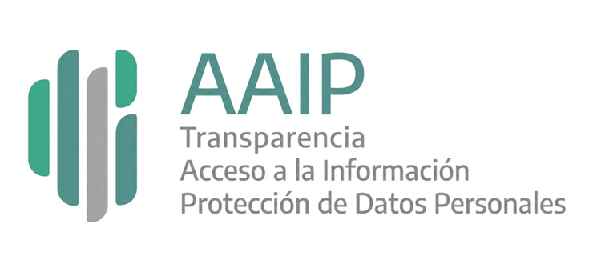

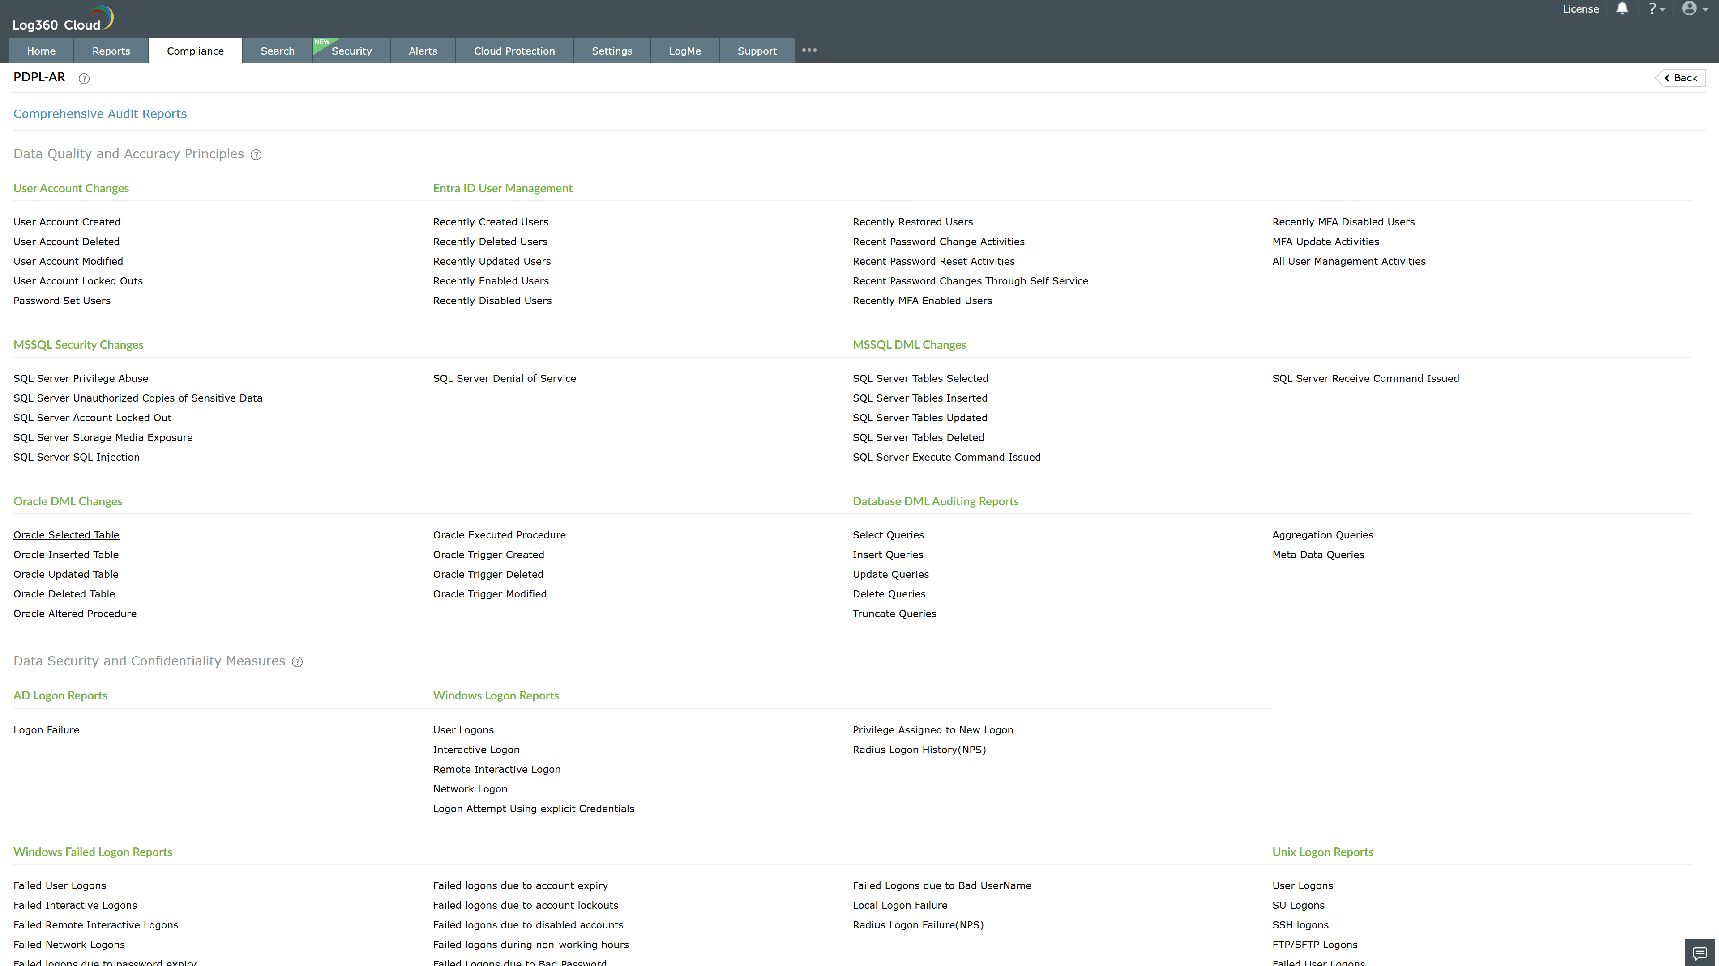
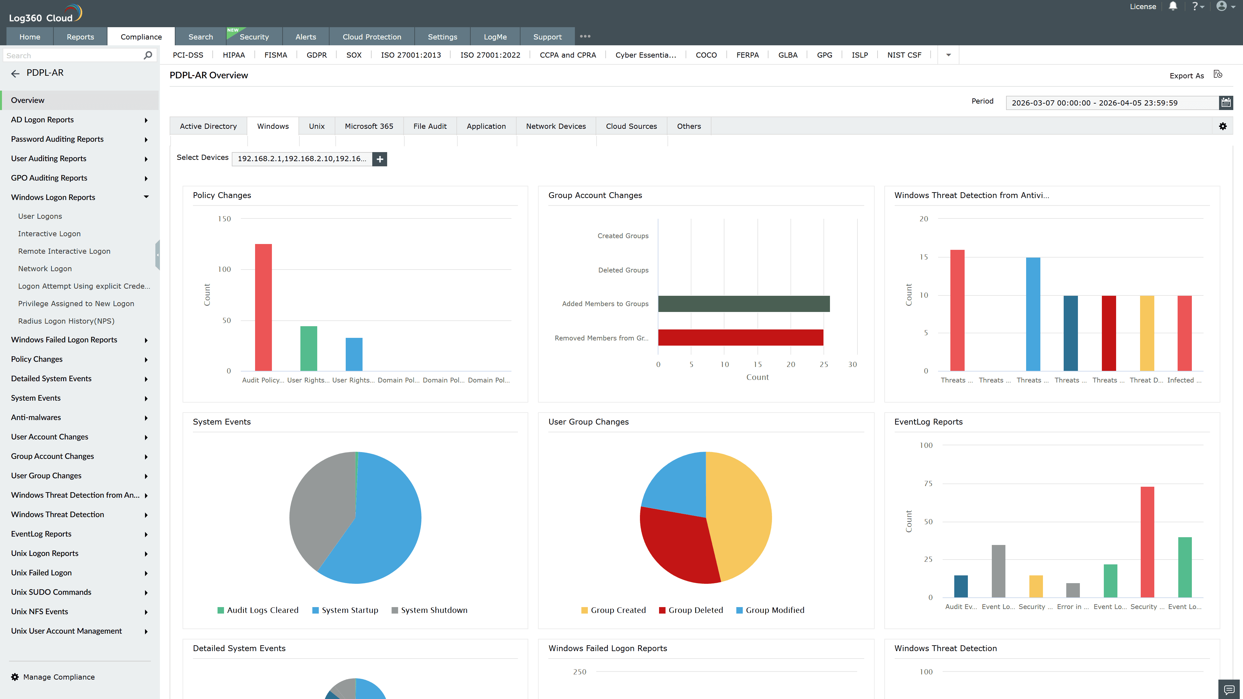
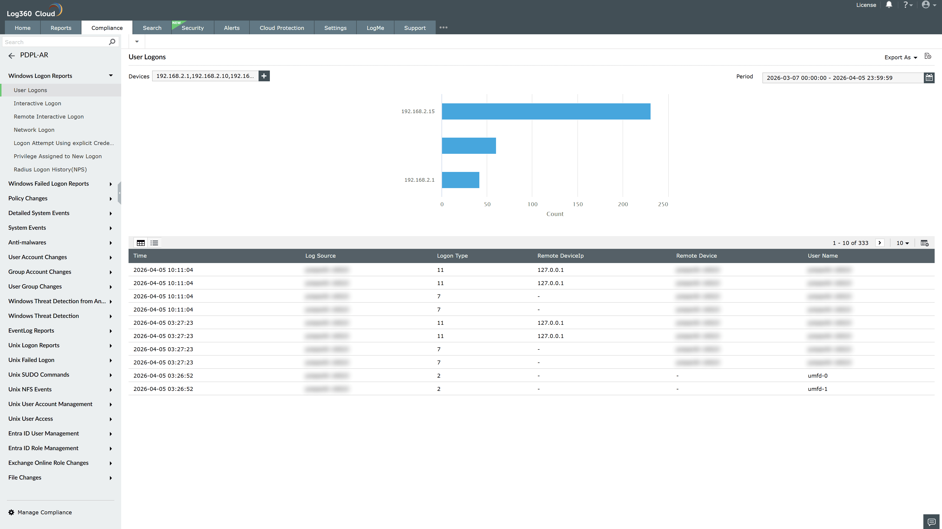
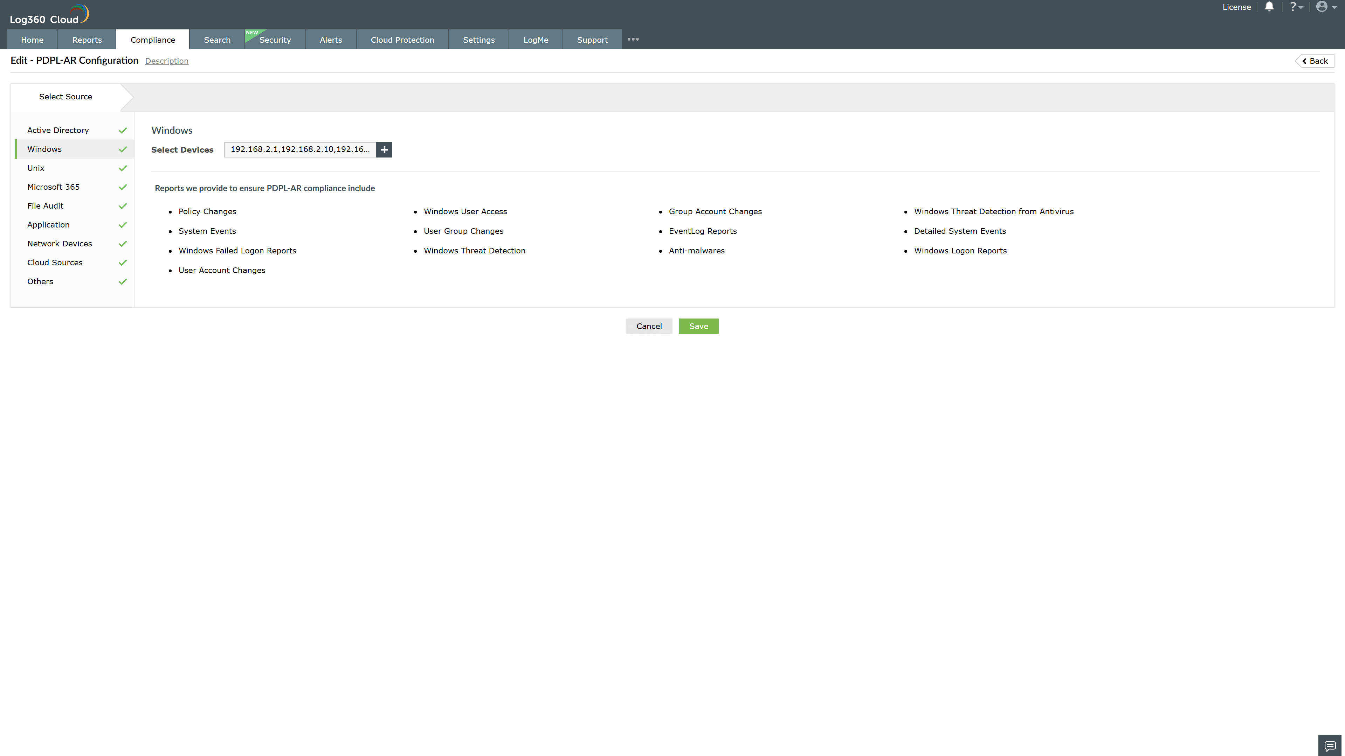
Valid Submission : Yes
Supported Editions : Free, Basic, Standard, Professional, MSSP
Help Document : https://www.manageengine.com/log-management/help/integrations/compliance-extensions.html
Help Video : Not provided
Tags : Log360, Compliance, Privacy monitoring, Data privacy, Regulatory compliance
Supported DCs : US, IN, JP, CA, AU, UK and EU
Privacy Policy:
Terms of Service:
Release Notes:
Predefined reports for the PDPL-AR.

